# KATHMANDU UNIVERSITY

DHULIKHEL, KAVREPALANCHOWK, NEPAL



**SUBJECT CODE: COMP 314**

*In the partial fulfilment of “Data Structures Revisited: Binary Search Tree”*

**Lab Report #3**

**Submitted To:**

Rajani Chulyado,PhD

Lecturer

Department of Computer Science and Engineering (DoCSE)

**Submitted By:**

Kamal Shrestha

Roll No.:49

6th Semester, 3nd Year

B.E. Computer Engineering

Submission Date:27th May 2019

Link to Github: <https://github.com/KamalShrest/CE_III_49_Lab3>

**Objectives:**

1. Implement binary search tree. Your implementation must support the

Following operations:

(a) Add a node to a BST

(b) Search BST for the requested key

(c) Find the smallest key

(d) Find the largest key

(e) Delete a key from a BST

(f) Inorder traversal

(g) Preorder traversal

(h) Postorder traversal

2. Write some test cases to test each operation listed above.

**Introduction:**

**Binary Search Tree:**

Binary Search Tree, is a node-based binary tree data structure which has the following properties:

* The left subtree of a node contains only nodes with keys lesser than the node’s key.
* The right subtree of a node contains only nodes with keys greater than the node’s key.
* The left and right subtree each must also be a binary search tree.  
  There must be no duplicate nodes.

**Basic Operations:**

Following are the basic operations of a tree −

* **Search** − Searches an element in a tree.
* **Insert** − Inserts an element in a tree.
* **Pre-order Traversal** − Traverses a tree in a pre-order manner.
* **In-order Traversal** − Traverses a tree in an in-order manner.
* **Post-order Traversal** − Traverses a tree in a post-order manner.

**Inserting a node**

A naïve algorithm for inserting a node into a BST is that, we start from the root node, if the node to insert is less than the root, we go to left child, and otherwise we go to the right child of the root. We continue this process (each node is a root for some sub tree) until we find a null pointer (or leaf node) where we cannot go any further. We then insert the node as a left or right child of the leaf node based on node is less or greater than the leaf node. We note that a new node is always inserted as a leaf node. A recursive algorithm for inserting a node into a BST is as follows. Assume we insert a node N to tree T.  if the tree is empty, the  we return new node N as the tree. Otherwise, the problem of inserting is reduced to inserting the node N to left of right sub trees of T, depending on N is less or greater than T.  A definition is as follows.

Insert(N, T)  = N   if T is empty

                     = insert(N, T.left)  if  N < T

                      = insert(N, T.right) if  N > T

**Searching for a node**

Searching for a node is similar to inserting a node. We start from root, and then go left or

right until we find (or not find the node). A recursive definition of search is as follows.

If the node is equal to root, then we return true. If the root is null, then we return false.

Otherwise we recursively solve the problem for T.left or T.right, depending on N < T or

N > T. A recursive definition is as follows.

Search should return a true or false, depending on the node is found or not.

Search(N, T) =  false   if T is empty

                     =  true    if T = N

                     = search(N, T.left) if N < T

                     = search(N, T.right) if N > T

**Deleting a node**

A BST is a connected structure. That is, all nodes in a tree are connected to some other

Node. For example, each node has a parent, unless node is the root. Therefore deleting a

Node could affect all sub trees of that node. We need to be careful about deleting nodes

from a tree. The best way to deal with deletion seems to be considering special cases.

What if the node to delete is a leaf node? What if the node is a node with just one child?

What if the node is an internal node (with two children). The latter case is the hardest to

resolve. But we will find a way to handle this situation as well.

**Case 1: The node to delete is a leaf node**

This is a very easy case. Just delete the node. We are done

**Case 2: The node to delete is a node with one child.**

This is also not too bad. If the node to be deleted is a left child of the parent, then we connect the left pointer of the parent (of the deleted node) to the single child. Otherwise if the node to be deleted is a right child of the parent, then we connect the right pointer of the parent (of the deleted node) to single child.

**Case 3: The node to delete is a node with two children**

This is a difficult case as we need to deal with two sub trees. But we find an easy way to handle it. First we find a replacement node (from leaf node or nodes with one child) for the node to be deleted. We need to do this while maintaining the BST order property. Then we swap leaf node or node with one child with the node to be deleted (swap the data) and delete the leaf node or node with one child (case 1 or case 2)

Next problem is finding a replacement leaf node for the node to be deleted. We can easily find this as follows. If the node to be deleted is N, the find the largest node in the left sub tree of N or the smallest node in the right sub tree of N. These are two candidates that can replace the node to be deleted without losing the order property.

Applications include:

* Using linear data structures to represent sets: insert, isMember, remove, all O(n)
* Using binary search trees to represent sets: insert, isMember (search), remove, all O(h) --- O(lg(n)) if we are lucky.

**Python Code:**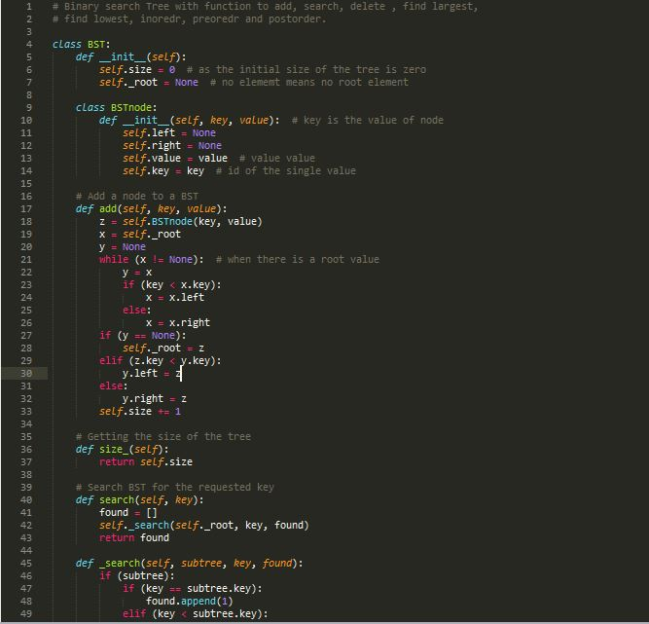

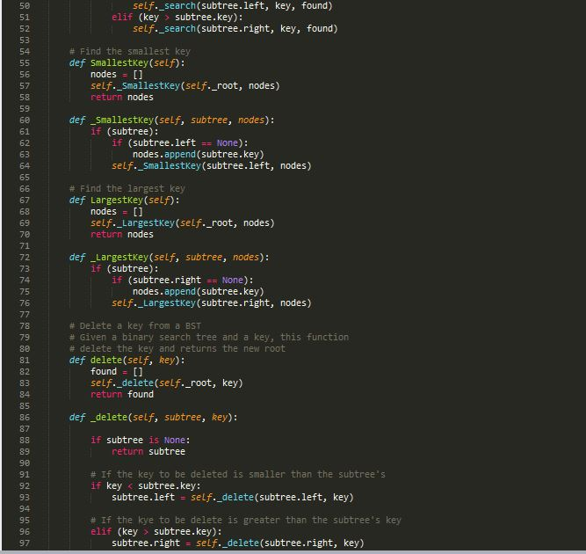

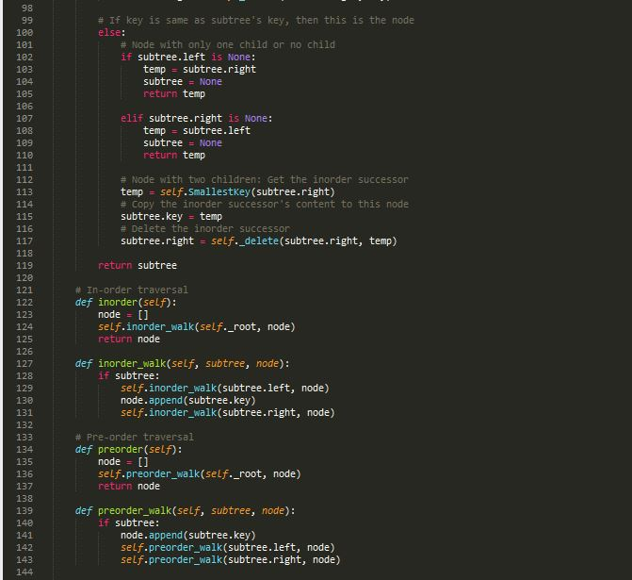

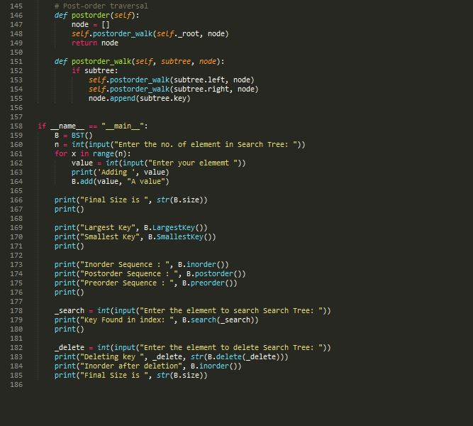

**Test Cases:**

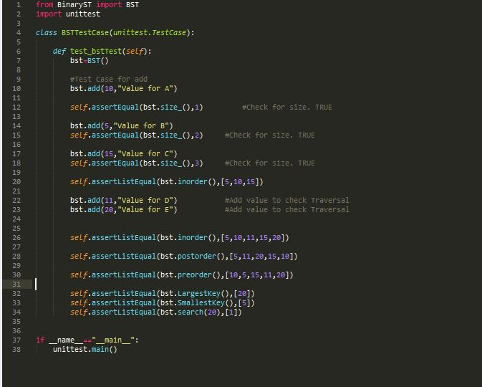

**Test Cases-Result:**

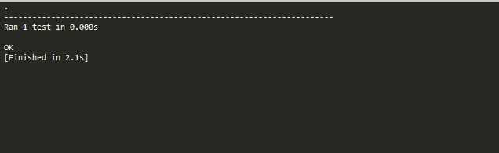

**Conclusion:**

Hence, several operations can be carried out in a binary search tree where the worst-case time of building a binary tree is O(*n*2). On average, binary search trees with *n* nodes have [O](https://en.wikipedia.org/wiki/Big_O_notation)(log *n*) height. However, in the worst case, binary search trees can have O(*n*) height, when the unbalanced tree resembles a linked list(degenerate tree). So using binary search trees to represent sets is asymptotically no worse than lists, and often better. If we can find an efficient way to insure that our BSTs remain balanced then we can do asymptotically better than with lists.